SOP Name | Haemagglutination assay (HAT)
SOP Identifier | LAB006 Haemagglutination assay
Edition | Version 1
Effective Date | 31/08/2021
Author | Rebecca Cox

SCOPE: This SOP applies to all staff, visitors, researchers and research staff working in VACCELERATE and affiliated labs.

- PURPOSE: This SOP outlines haemagglutination method for detection of SARS-CoV-2 antibodies targeted agains the receptor binding domain.

POLICY
VACCELERATE works within the guidelines and regulations of the EU CT Directive 2001/20/EC, GCP Commission Directive 2005/28/EC, ICH/GCP and with all other local and international applicable regulatory requirements.

ROLES AND RESPONSIBILITIES

VACCELERATE and affiliated laboratory staff carrying out this assay are responsible for its accurate and safe implementation.

DEFINITIONS

- RELATED DOCUMENTS

PROCEDURES
Standard Operating Procedures:
Finger Prick Test.
Only 5 µl of blood is required for this test. However, we advise collecting 250 µl if possible as the excess can provide material for control measurements of antibodies by RBD ELISA or neutralisation tests.

Equipment and reagents Required
- Disposable Lancet
- 100 µl, 20 µl pipettes
- V bottom 96 well plate, Eppendorf Tubes
- EDTA solution (add 5 ml PBS to 10 ml K2EDTA blood collection tube, store at 4 °C = 3.6 mg/ml K2EDTA) or use BD Microcontainer K2EDTA Tubes REF 365975 to collect 250-500ul of blood.
- If many samples are to be collected we recommend placing them in numbered and dated boxes (cardboard 10x10 with spacers) in rows of 6 samples; 8 rows to a box = 48 samples per box. This is equivalent to half of a 96 well plate. When processing and plating out the samples this arrangement will help prevent errors.
- PBS
- IH4-RBD Reagent diluted 2 µg/ml in PBS. This remains active for at least 1-2 weeks stored at 4 °C. It may need an antibacterial agent if this is envisaged.
- Control Antibody CR3022 2 µg/ml or EY-6A 20ug/ml.

Method: (see ppt “Townsend-Joly HAT” v 31-8-20 and BioRxiv reprint).
Preparation : Clean Hands, warm digit. Prepare a plate (96 well V bottom) labelled with Date and Time.
- Prick skin on outer finger pulp with disposable, single use BD or another Lancet.
- Wipe away first drop of blood with sterile towel/swab
- Massage second drop
- Take minimum of 5 µl blood with 20 µl Gilson pipette, mix immediately into 20 µl K2EDTA/PBS in Eppendorf. If possible, take 25 µl of blood and mix into 75 µl EDTA solution. Another approach is collection of blood drops into a BD Microtainer K2E EDTA lavender vials, REF 365975, that take 250-500 µl.
- For 5 µl sample dilute to 200 µl with PBS (add 175 µl PBS). For larger samples place 25 µl sample into 1000 µl in PBS. Serum is now at 1:40, and the red cells are at the correct density (~1% v/v assuming a haematocrit of 40%) to give a clear tear drop.
- Plate 100 µl in each well of V bottomed microtitre plate labelled T (Test). When the plate is full, with an 8-channel pipette resuspend the red cells and transfer 50ul to identical control plate labelled PBS Control. Change tips for each column.
- Add 50ul IH4-RBD (2ug/ml working solution) to all wells of the Test Plate. Add 50ul PBS to all wells of the PBS Control plate. Note Time on the plates. The next set of 96 samples can now be assembled while incubating the plates containing the first set.
- Set up a new plate for a positive control. Place 50ul of 1:40 blood from a known seronegative donor in two wells. Add 10 µl of control anti RBD Mab CR3022 (2 µg/ml stock in PBS, 20 ng/well) to each. Add 50ul IH4-RBD (2ug/ml) to one well and PBS to the other. Note Time on the plate. This control is only needed for each batch of test plates to ensure that the reagents are working.
- Incubate 1 hour at RT for Red Cells to form a pellet in the “-ve“ wells.
- Tilt plates against a well-lit white background for ~30 seconds to allow Tear drop to form in “-“ wells.
- The presence of antibodies to RBD is shown by loss of Tear Drop formation in the “T“ and “+“ wells. Occasionally a partial tear drop forms – these wells are counted as Negative (see pp “Townsend-Joly HAT” v 28-7-20).
- Photograph the plate to record the results with the date and time. Results can be reviewed and tabulated later. Taking the picture from a distance and using the zoom function helps to take a clear picture of all wells in a 96-well plate.
- Example: G has given a positive result, H, A and B are negative. Note that tilting the plate is absolutely necessary because sometimes the agglutinated red cells form a mat as here, sometimes a button that fails to flow into a teardrop. The negative (PBS) control sample should be done on every sample for comparison. The Positive control induced by CR3022 is used to check that all the reagents are working, and that the Glycophorin epitope recognised by VHH-IH4 is present on the red cells. Absence of the IH4 epitope should be very rare (Habib 2013). For setting up cohorts a positive control on every sample is therefore not necessary, but should be included in every batch of samples.
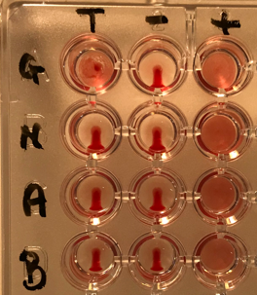
- If a 25 µl sample of blood was taken from the finger prick into 1ml PBS there should be 900µl of the 1:40 diluted blood left. The red cells can be spun out and washed x3 with PBS and resuspended in the same volume of PBS for use in a titration (described below) with the first s/n, which is 1:40 serum. This can also be used in confirmatory ELISA or other tests.
- A simpler and less time-consuming partial titration with the donors own red cells can be done on large numbers of samples without the need for a microfuge/centrifuge: i) prepare 2 x1 ml aliquots of 1:40 blood by adding 25ul FP blood to 0.975 ml PBS in two Eppendorf tubes. These will be used to prepare 1:40 and 1:320 dilutions for testing. Either leave the tubes upright overnight in fridge (if handling many samples), or microfuge one of the tubes 30s at 2K to settle the red cells. Remove 875ul of the s/n (= 1:40 serum, which can be stored for other tests) from tube 2 and replace with 875 ul PBS and resuspend the red cells. These red cells are now in 1:320 of serum. Take 50 µl aliquots of the 1:40 and 1:320 preps for the initial test (50 µl 1:40 blood + 50 µl 2ug/ml IH4-RBD, versus 50 µl 1:40 Blood + 50 µl PBS -ve control). There is enough sample to test several variant RBDs if the reagents are available. In our studies of cohorts 100% of samples positive in HAT at 1:320 have detectable neutralising activity.

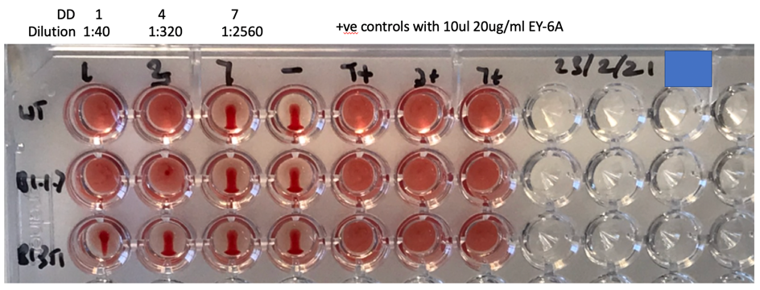
The picture shows a typical result from a convalescent donor after a symptomatic infection: Positive at 1:320 on WT, and B1.1.7 RBDs, partial/negative response on B.1.351.

Spot test on Stored Serum samples.
This is designed to match the Finger Prick Test

Equipment and Reagents:
- Fresh O-ve blood diluted in PBS 1:20 = ~2% Red Cells. Resuspend by inverting gently ~12 times.
- IH4-RBD Reagent 2 µg/ml
- V bottom plates, numbered, dated, timed (helps when timing many plates).

- Plate out 50 µl of 1:20 sera in alternate columns 1,3,5,7,9,11 (add 2.5 µl serum to 47.5 µl PBS, 8 at a time).
- Add 50 µl 2% red cells (so that now serum is diluted to 1:40 and red cells at ~1% v/v)
- Mix and transfer 50/100 µl to neighbouring columns 2,4,6,8,10,12 for -ve controls.
- Add 50 µl IH4-RBD reagent (2 µg/ml in PBS = 100 ng/well) to Columns 1,3,5,7,9,11
- Add 50 µl PBS to columns 2,4,6,8,10,12.
- Inc 1 hr RT
- Tilt at ~80º for 30s
- Photograph
- Read as Positive = No teardrop (Red), Negative <1:40 = partial teardrop (Orange), Neg = complete teardrop .
- Two readers should read the plates independently, and disagreements resolved by taking the lesser reading.

Example of Plate:
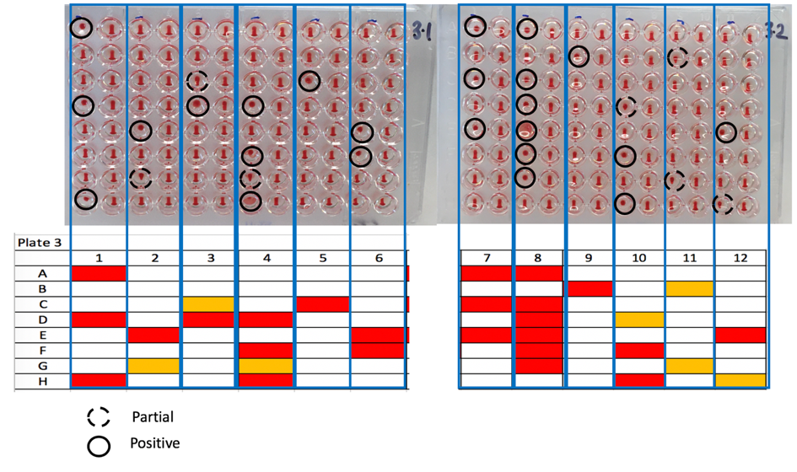

Titration of Serum Samples. It can be useful to titrate samples. A strong positive can titrate out to 1:640 or more.

Equipment and reagents required
- As above for the finger-prick (FP) test
- To titrate the sample a source of red cells is required. In principle this can be the washed autologous red cells from the FP sample. If titration is to be done at some later time a source of O-ve red cells will be required. This can be a fresh EDTA sample of fresh O-ve blood diluted to 1:40 with PBS. Separating and washing the O-ve red cells is not necessary, as long as they come from a donor seronegative for SARS-2 antibodies. The blood stored at 4 °C for up to a week was still usable. 10 ml of O-ve blood is sufficient for 8,000 test wells.
- Stored O- red cells from the Blood Bank. This source can be used but the stored cells behave significantly differently from fresh red cells: 1) they come with Hct ~80% and need careful dilution to find a concentration – usually 1:80 – that forms a clear teardrop, 2) they take 2 hrs to settle 3) the teardrops take longer to form – keep the plates tilted until the teardrops have reached the edge of the negative control wells (may take ~2 minutes), 4) the end points are less sharp – usually 2 DD in front of the first well with definite flow in teardrop and 5) the endpoints tend to be 1 DD to right of those in fresh red cells: In the example below 20ug/ml EY-6A titrates to DD 7 = 8ng/well. Some wells with partial flow form wing like structures – scored as negative. In all cases the prep needs to be checked with the reagent for the presence of antibodies to RBD (agglutination in the PBS control wells). This is becoming increasingly COMMON. If found the red cells must be washed 3 x and rechecked before using them.
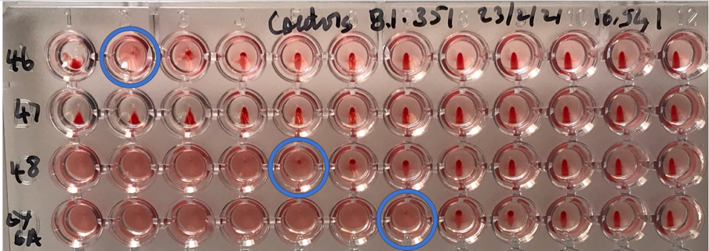

Method: as above. We have found that titrating volumes in 50 µl is more accurate and less error prone than volumes of 25 µl.

- Separate the red cells from the FP sample either by letting the red cells settle o/n at 4 °C, or by centrifugation.
- Decant the s/n = 1:40 serum into an Eppendorf or other sterile tube.
- If the autologous red cells are to be used as indicator, these should be washed three times to remove antibodies and resuspended in the original volume = 1:40 ~1% v/v red cells.
- If O-ve blood is to be used prepare at 1% v/v (fresh seronegative blood can simply be diluted to 1:40). Resuspend by inverting ~12 times.
- Place 100 µl of 1:40 sample from FP in first column in A1 -H1. Prepare DD with 50/100 µl from column 1 with PBS in columns 2-11 (1:40 to 1:40,960), leave the last well with PBS alone in row Column 12.
- Add 50 µl 1:40 resuspended red cells to all wells. This will have to be done for individual rows for washed autologous red cells.
- Add 50 µl IH4-RBD (2 µg/ml) to all wells
- Allow to settle for 1 hr
- Tilt plate for 30s and photograph. The titre is defined by the last well in which the tear drop fails to form. Partial teardrop regarded as negative.

Titration of Stored Serum Samples.
As for titration of finger prick samples.

- Dilute Serum samples to 1:20 in 50 µl PBS (2.5 µl to 47.5 µl) in V bottomed plate in columns 1, Rows A-H.
- Prepare doubling dilutions in columns 1-11 (1:40 to 1:40,960), PBS control in column 12.
- Add 50 µl 1:40 O-ve red cells (1:40 fresh EDTA blood sample diluted in PBS or ~1:80 stored O- RBC from BTS)
- Add 50ul IH4-RBD (2 µg/ml, 100 ng/well) [the O-ve red cells and IH4-RBD can be pre-mixed and added together to save a step]
- Allow to settle for 1 hr
- Tilt plate for 30s and photograph. The titre is defined by the last well in which the tear drop fails to form. Partial teardrop regarded as negative.

Batch Variation: we have detected very little batch variation in the IH4-RBD reagent, and samples before and after lyophilisation titrate to the same point. If in doubt titrate the CR3022 MAb and the IH4 reagent in two dimensions as follows:

Method
- Make up CR3022 to 1.28 µg/ml in PBS
- Make up IH4-RBD at 32 µg/ml in PBS
- Plate 50 µl CR3022 in column 1. Prepare DD columns 1-7, PBS in Column 8 (32-0.5 ng/well)
- In a separate plate distribute 60 µl IH4-RBD 32 µg/ml in row 1. Prepare DD rows 1-7 (A-G) , PBS in Row 8 (H) (= 16 µg/ml to 0.25 µg/ml = 800 to 12.5 ng/well) .
- Add 50 µl 1:40 (1% red cells) blood (does not need to be O-ve) to all wells.
- Add 50 µl of the IH4-RBD DDs to rows 1-8 (800 - 12.5 ng/well).
- Allow to settle for 1 hr
- Tilt plate for at least 20s and photograph. The titre is defined by the last well in which the tear drop fails to form. Partial teardrop regarded as negative.
- Select the concentration of IH4-RBD that detects the lowest concentration of added CR3022.

Example:
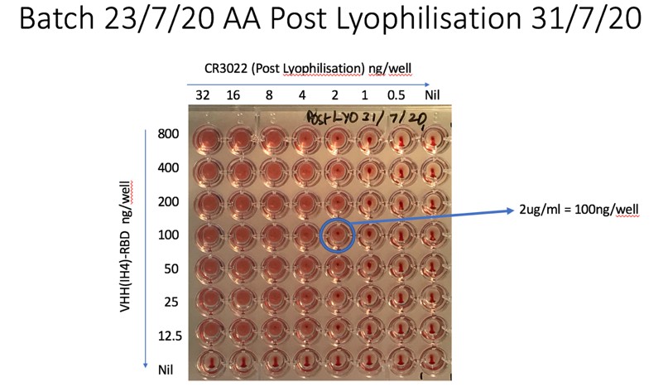

REVIEW AND REVISION

- DOCUMENT HISTORY

Version Number | Effective Date: | Summary of changes from  previous version: | Edited by: (name and role)
01

- APPENDICES

