SOP Name | Anti-Sars-Cov-2 (Spike, Nucleocapsid and RBD) IgG Protocol for MSD Platform
SOP Identifier | LAB008 Anti-RBD Ab quantification
Edition | Version 1
Effective Date | 30/08/2021
Author | Alejandro Abner Garcia Leon

- SCOPE: This SOP applies to all staff, visitors, researchers and research staff working on VACCELERATE protocols.

- PURPOSE: To outline the methods for quantifying anti-RBD antibodies using MSD platform.

- POLICY: VACCELERATE works within the guidelines and regulations of the EU CT Directive 2001/20/EC, GCP Commission Directive 2005/28/EC, ICH/GCP and with all other local and international applicable regulatory requirements.

- ROLES AND RESPONSIBILITIES
- The investigators should stipulate the appropriate processing requirements for all prospective studies with VACCELERATE lab staff prior to the study's initiation.
- It is the responsibility of the research personnel carrying out this procedure to ensure that all steps are completed both competently and safely.

- DEFINITIONS

- RELATED DOCUMENTS

- PROCEDURES
7.1. PRINCIPLE OF THE ASSAY
MSD V-PLEX Sars-Cov-2 serology kits quantitively measure the antibodies to antigens related to Sars-Cov-2 and various variants of coronaviruses. Different panels provide different combinations of antigens that are pre-coated on a 10-spot multi-spot plate (see Kit description for more details). Antibodies in the sample will bind to the specific antigen and this antigen-specific antibody is then detected by MSD SULFO-TAG™ labelled detection antibody which is specific for a particular Anti-Human Ig antibody (IgG, IgM and IgA). The plate when read on MSD instrument measures light emitted from MSD SULFO-TAG.
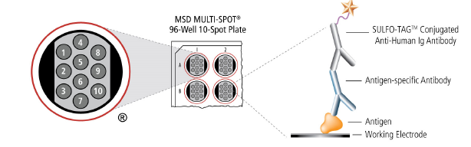
Figure 1: MSD V-PLEX SEROLOGY ASSAY REACTION

7.2. KIT DESCRIPTION
MSD V-PLEX SARS-COV-2 Panel 2 Kit will be used to quantitatively measure IgG against the below highlighted antigens that are pre-coated on a 10-spot multi-spot plate. Rest of the spots are blocked. The kit should also include a reference standard, controls, plates, detection capture antibodies and other necessary reagents.
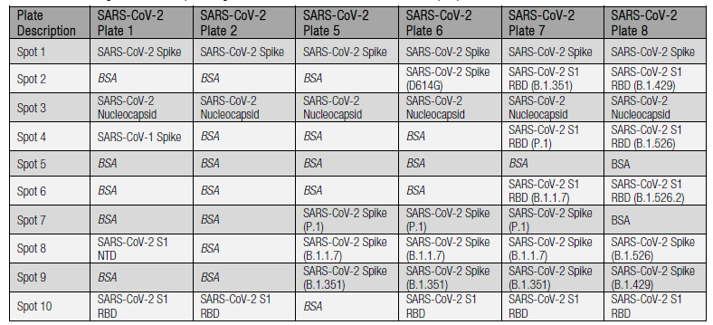
Figure 2: EXAMPLE OF DIFFERENT PRE-COATED ANTIGEN PLATES AVAIBLE IN MSD V-PLEX SEROLOGY KITS.

7.3 REAGENTS NEEDED
- MSD V-PLEX Sars-Cov-2 Serology panel 2 kit
- Deionised water
- Plate sealers (3 per plate) – Cruinn, 676001
- Vacuum filter sterilization units (0.22µm) – Fisher Scientific, 10440011
- Sterile reservoirs – Coring 4870

7.4 RECOMMENDATIONS AND BEST PRACTISES

- Use filtered pipette tips and use a fresh pipette tip after each reagent addition.
- For long-term studies using multiple plates of the same assay, it is recommended that the same Linker be coupled with the same antibody for the duration of the study.
- While most lyophilized material is located at the bottom of the vial, some may be on the sides or cap. To ensure that all lyophilized powder is reconstituted, it is recommended to vortex the vial in 3 short pulses (upright, inverted, upright) after the solution sits at room temperature for 15-30 minutes.
- Prepare Calibrator Standards and samples in polypropylene microcentrifuge tubes. Use a fresh pipette tip for each dilution and mix by pipette mix after each dilution.
- Use reverse pipetting when necessary to avoid the introduction of bubbles. For empty wells, pipette gently to the bottom corner.
- Avoid prolonged exposure of the detection antibody (stock or diluted) to light. During the antibody incubation step, plates do not need to be shielded from light (except for direct sunlight).
- Avoid bubbles in wells during all pipetting steps as they may lead to variable results. Bubbles introduced when adding Read Buffer T may interfere with signal detection.
- Plate shaking should be vigorous, with a rotary motion between 500 and 1,000 rpm. Binding reactions may reach equilibrium sooner if you use shaking at the middle of this range (~700 rpm) or above.
- Reversing plate orientation between wash cycles may improve assay precision.
- Gently tap the plate on a paper towel to remove residual fluid after washing.
- If you plan to coat U-PLEX plates for later use, keep each plate pouch and the desiccant that came with the plate. After the plates are incubated with the coating solution, wash them with MSD Wash Buffer or PBS-T, then return each plate to its original packaging with the desiccant, and seal.
- If an incubation step needs to be extended, leave the sample or detection antibody solution in the plate to keep the plate from drying out.
- Remove the plate seal prior to reading the plate.
- Make sure that the Read Buffer b is at room temperature (20-26 C) when added to a plate.
- Do not shake the plate after adding Read Buffer b.
- To improve inter-plate precision, keep time intervals consistent between adding Read Buffer B and reading the plate. Unless otherwise directed, read the plate as soon as possible after adding Read Buffer B.
- If the sample results are above the top of the calibration curve, dilute the samples and repeat the assay.

7.5 REAGENT PREPARATION
MSD Blocker A solution
Filtered MSD Blocker A 5X is diluted in PBS to prepare a 1% MSD Blocker A that is used block the plate.
To prepare 50 ml of a 1% MSD Blocker A add 10 ml of the 5X Filtered MSD Blocker A to 40 ml of PBS.
MSD Wash Buffer
The wash buffer is provided at 20X stock concentration, and the working concentration is 1X. For on plate (approximately) Add 15 ml of 20X MSD Wash Buffer to 285 ml of Deionized water.
Note: MSD also suggest a PBS + 0.05% Tween 20 solution as an alternative to wash buffer.
Assay and Antibody Diluent
Use MSD Diluent 100 as assay and antibody diluent. Do not dilute.
Calibrator Preparation
The kit includes a serum-based reference standard - Reference Standard 1 which is used to calculate concentration of IgG for multiple antigen coated on the plate.
Reference standard requires a 10-fold dilution to generate highest standard point in the curve, CAL-01 or Standard 1. It is then further diluted 4-fold to generate rest of the point of the curve.
Add 50 ul of Standard 1 to 150 ul of Diluent 100 to generate Standard 2. Perform 5 more similar more 1:4 dilutions to generate Standard 3 to Standard 8.
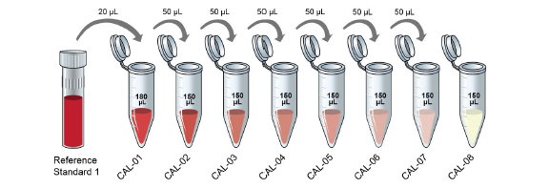
Figure 3: Standard preparation for MSD V-PLEX COVID-19 Sars-Cov-2 panel-2 kit.
Control Preparation
Each of MSD serology kit consists of 3 levels f controls with assigned concentration for IgG. IgM, IgA. Refer to MSD V-PLEX Sars-Cov-2 serology kits product insert to check the assigned concentrations.
Each control is supplied at the working concentration. Do not dilute. Thaw the control on ice, vortex mix it briefly and add 50 ul of the control to the assigned well.
Note: Stock control is stable for 5 years from the date of manufacturing when stored at
≤- 70° C and is stable for up to 5 freeze and thaw cycles.

Sample Preparation
Samples are prepared by diluting with Diluent 100. The optimal dilution is to be decided by the user. Typically, the dilution would be in the range of 100-fold to 5000-fold dilution.
For example: To make 200 ul of 1:100 dilution of one sample.
Add 2 ul of sample to 198 ul of Diluent 100.

To make 200 ul of 1:5000 dilution for one sample.
Add 2 ul of sample to 198 ul of Diluent 100. And then add 4 ul of this diluted
sample to diluent 100.

Detection Antibody
Detection Antibody is provided at 200X stock solution, and the working solution is 1X diluted with Diluent 100.
For example: For 1X detection antibody solution for 1 plate (96 wells).
Add 25 ul of detection antibody to 4975 ul of Diluent 100.
MSD GOLD Read Buffer B
MSD provides MSD GOLD Read Buffer B ready for use. Do not dilute.

7.6 PROTOCOL
Add 150 ul/well of Blocker A solution of the plate.

Seal the plate with a plate sealer and incubate at room temperature on plate shaker at 750 rpm for 30 minutes.

Wash the plate 3 times with 150 ul/well of MSD Wash Buffer.

Add 50 ul of diluted samples, standards and controls to the plate.

Seal the plate with a plate sealer and incubate at room temperature on plate shaker at 750 rpm for 2 hours.

Wash the plate 3 times with 150 ul/ well of MSD Wash Buffer.

Add 50 ul/well of 1X detection antibody solution to the plate.

Seal the plate with a plate sealer and incubate at room temperature on plate shaker at 750 rpm for 1 hour.

Wash the plate 3 times with 150 ul/ well of MSD Wash Buffer.

Add 150 ul/well of MSD GOLD Read Buffer B to the plate.

Read the plate with the MSD instrument.

- REVIEW AND REVISION

- DOCUMENT HISTORY

Version Number | Effective Date: | Summary of changes from  previous version: | Edited by: (name and role)
01

- APPENDICES

